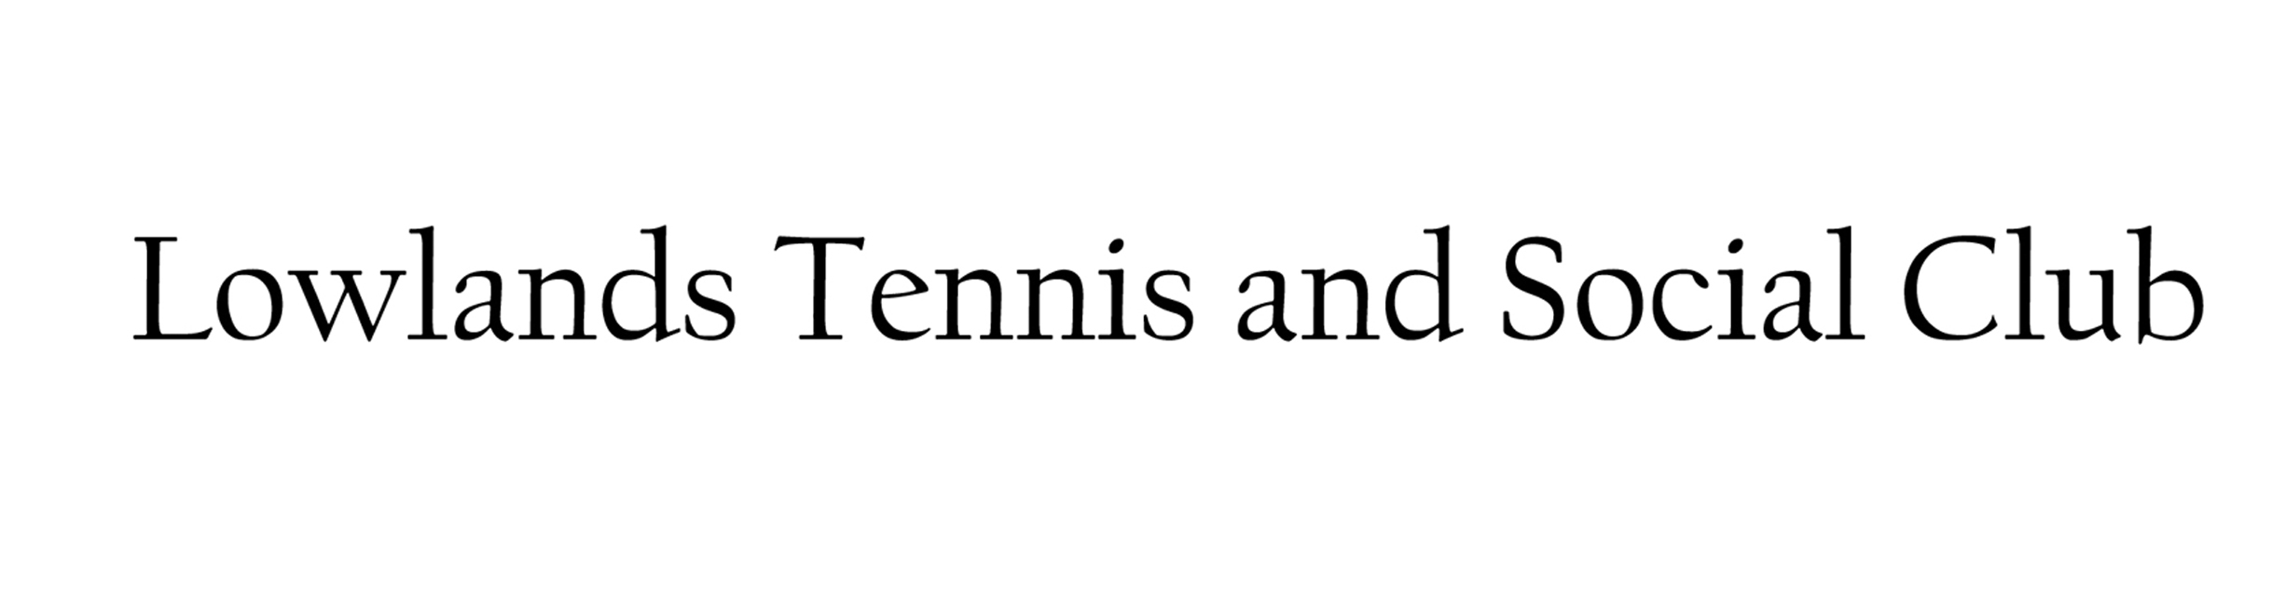
Lowlands Road, Eastcote, Middlesex HA5 1TU www.lowlandsclub.com

APPLICATION FOR MEMBERSHIP
(one form per member)

NAME (block capitals) Mr/Mrs/Ms/Other: | Click or tap here to enter text.
ADDRESS: (inc Post Code) | Click or tap here to enter text.
TELEPHONE NO.: | Click or tap here to enter text.
EMAIL: (please write legibly) | Click or tap here to enter text.
DATE OF BIRTH: | Click or tap here to enter text.
NAME & CONTACT DETAILS OF PARENT/GUARDIAN:  (if under 16yrs) | Click or tap here to enter text.

PLEASE TICK ONE:
ADULT TENNIS:  (Affiliated to Middx LTA) | Full Tennis ☐ | Intermediate Tennis ☐ |  | Social Tennis ☐
Note: For Junior Tennis Membership see Junior Member Application Form
TABLE TENNIS: (Team Players Only) ☐  Members of Wembley and Harrow Table Tennis League |  |  | SOCIAL: ☐  (Inc social Table Tennis and Snooker)

NOTE: ALL TENNIS AND TABLE TENNIS MEMBERS ARE AUTOMATICALLY SOCIAL MEMBERS.

HEALTH DECLARATION
I confirm that I am fit to take part in all club activities and have not been advised otherwise by a GP or Hospital Doctor. | ☐
Contact Name & Phone Number in the Event of an Emergency | Click or tap here to enter text.

DATA PROTECTION (GDPR)
By submitting your personal information to us and ticking the acceptance box on this application form, you signify in a pro-active way, your consent to our using the information for purposes outlined in the Data Protection (GDPR) policy available from our website – www. Lowlandsclub.com. If at any time you wish to update the information which we hold about you or if you wish to stop receiving information from the club please contact the club at info@lowlandsclub.com. | ☐

PHOTOGRAPHY
I agree to the possibility of having my/our photo taken at Club events and that these photos may be used to promote the club on Social Media such as the Club’s Facebook page. | ☐

By signing this form, I agree to become a member of Lowlands Club and Abide by the Club Rules.
Signature: | Click or tap here to enter text. | Date: | Click or tap to enter a date.

Completed Forms should be returned to the Membership Team at the above address.
Forms may also be placed in the club post box (to the left of the front door) or scanned to info@lowlandsclub.com
Dec 2021

