**By signing below I agree to:**

* **Become a member of Lowlands Tennis Club and abide by the club rules.**
* **Become a BTM member (FREE sign up on the LTA website www.LTA.org.uk/BTMTC) and agree that you/your child will abide by the terms and conditions of British Tennis Membership.**
* **Data Protection Statement: I agree that the Club can use my personal data (name, address, phone number and e-mail) for membership purposes and for sending me information relating to those purposes by post, e-mail or SMS.**

Signature of Parent

|  |  |  |  |  |  |  |  |  |  |
| --- | --- | --- | --- | --- | --- | --- | --- | --- | --- |
| Child’s Name: | Click or tap here to enter text. | | | Male: | ☐ | Female: | ☐ | Date of Birth: | ___/___/___ |
| Any Medical Conditions: | | Click or tap here to enter text. | | | | | | | |
| 2nd Child’s Name: | Click or tap here to enter text. | | Male: | | ☐ | Female: | ☐ | Date of Birth: | ___/___/___ |
| Any Medical Conditions: | | Click or tap here to enter text. | | | | | | | |

|  |  |  |  |  |
| --- | --- | --- | --- | --- |
| Parents Name: | Click or tap here to enter text. | | | |
| Address: | Click or tap here to enter text. | | | |
| Post Code: | Click or tap here to enter text. | | Emergency Contact Number: | Click or tap here to enter text. |
| Email Address: (please write legibly) | | Click or tap here to enter text. | | |

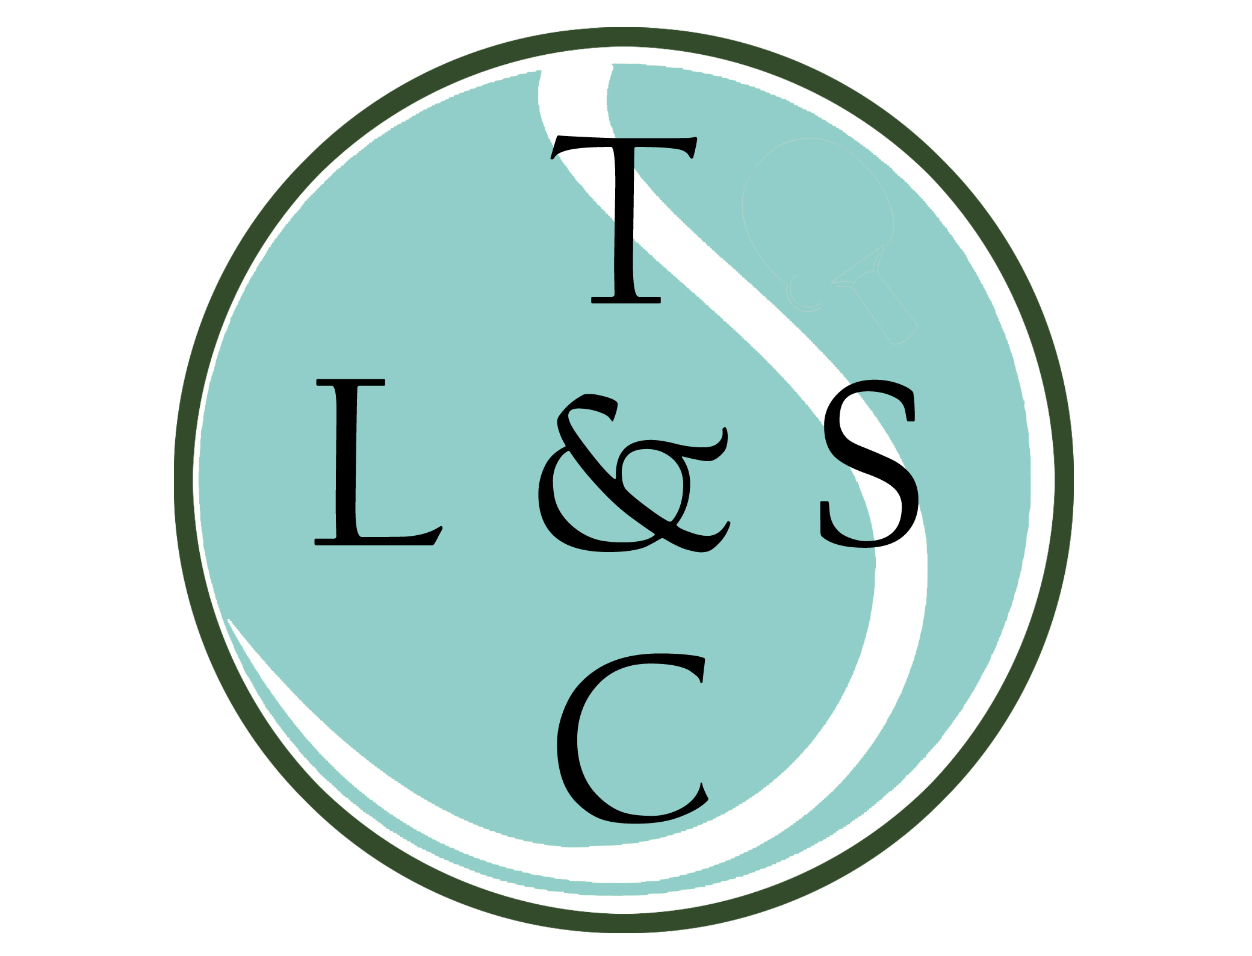

Lowlands Road, Eastcote, Middlesex HA5 1TU [www.lowlandsclub.com](http://www.lowlandsclub.com)

Feb 2023

If you have any questions, regarding coaching please don’t hesitate to contact Head Coach Simon Gibaut on

07764 501 117 or [simon@sgtennis.co.uk](mailto:simon@sgtennis.co.uk)

Alternatively, if you need more information on payment please contact the Membership Team at info@lowlandsclub.com

Please fill out the form below and return to Lowlands Club, Lowlands Road, Eastcote, Middlesex, HA5 1TU. Forms may also be placed in the post box at the club (left hand side of the front door), or scanned to info@lowlandsclub.com

**Mini Member** - £37 per year

Under 11 on 01/03/2023

* Use of mini court (or court 1 if available)
* Discount on group and individual coaching

**Junior Member** - £54 a year

11ys – 18ys (Under 19 on 01/03/2023)

* Use of courts (some restrictions apply) including use of floodlights.
* Discount on group and individual coaching
* Use of clubhouse until 9pm every night which includes darts, pool, tv. Snacks and drinks can be purchased from the bar.
* FREE pool on Wednesday and Friday evenings after coaching sessions until 9pm
* Club tournament organised for players of a suitable standard
* Entry into Wimbledon ticket ballot (must be a BTM member and have ‘opted in’ to the the ballot on the LTA website)

Junior Tennis Membership Form

1st March 2023 – 28th Feb 2024